

**Product Dissection for WhatsApp**

### **Company Overview:**

WhatsApp, created in 2009 by Brian Acton and Jan Koum, changed the way we communicate. It made sending messages and sharing media quick and easy. When Facebook bought it, WhatsApp became even more popular and strong in the world of messaging apps. It has a simple yet powerful design with lots of useful features. WhatsApp is all about keeping our conversations private and secure through end-to-end encryption. More than 2 billion people use it every month, showing how much everyone loves it. It's like a pillar in how we communicate nowadays, connecting people globally in an instant.

### 

### **Product Dissection and Real-World Problems Solved by WhatsApp:**

WhatsApp, a widely used messaging app, has skillfully overcome real-world hurdles through its clever features and user-focused design. With a strong emphasis on privacy and easy communication, WhatsApp connects people across the world, addressing the challenge of distance.

At its core, WhatsApp lets users chat in real-time, sharing messages, voice notes, and making video and voice calls. This helps bridge gaps caused by borders and time differences, ensuring we stay close to our loved ones and colleagues.

WhatsApp's commitment to safeguarding user communications through end-to-end encryption addresses privacy concerns in the digital age, building trust in our exchanges.

Furthermore, WhatsApp's features like group chats and multimedia sharing enhance collaboration and creative expression, catering to both personal and professional needs.

Innovative updates and multimedia sharing give us a way to share experiences and emotions, addressing our need for self-expression and connection, even when physically apart.

In summary, WhatsApp's smart design has adeptly handled real-world challenges by offering a secure and user-friendly platform for communication and self-expression. Its dedication to privacy, seamless connections, and creative expression has made it an essential tool for millions globally, providing practical solutions for diverse user needs.

### **Case Study: Real-World Problems and WhatsApp Innovative Solutions**

WhatsApp is a top messaging app that's made communication better and overcome challenges using new ideas. It listens to what users need and uses smart technology. WhatsApp helps connect people, express themselves, and have better talks online.

#### **Problem 1: Privacy Concerns:**

**Real-World Challenge:** Nowadays, people worry about their private info being shared online, which makes them uneasy about using digital communication.

**WhatsApp's Solution:**WhatsApp solves this by making messages super secure with end-to-end encryption. Only the person sending and the person getting the message can read it. This strong safety tool creates a private and safe space for talking. By keeping your privacy in mind, WhatsApp deals with the real-world problem of data safety worries, making it a top pick for important talks.

#### **Problem 2: Regulatory Compliance and Legal Issues:**

**Real-World Challenge:**The changing online world has rules and laws that are different in various places. This makes it hard for apps to keep everyone's privacy safe when the law is watching.

**WhatsApp's Solution:**WhatsApp deals with this by being very careful about privacy and following the rules. They use strong ways to keep data safe and are clear about how they use it. This makes sure they follow the laws and keeps your chats safe and private.

#### **Problem 3: Misinformation and Fake News:**

**Real-World Challenge:** Nowadays, it's tough to know what's true and what's not on the internet. False stories can spread easily, causing confusion, disagreements, and sometimes even harm to people and communities.

**WhatsApp's Solution:**WhatsApp fights against wrong information by using different plans to stop fake news. They teach users how to spot false stories and rumors, asking them to check before sharing. Also, they put limits on forwarding messages and mark messages that are forwarded. This helps people check if the news is real or not. WhatsApp wants users to be careful and share information responsibly to make the online community better.

#### **Problem 4: Spam and Unsolicited Messages:**

**Real-World Challenge:** A lot of unwanted messages and spam fill up our phones, making it hard to have real conversations and causing annoyance.

**WhatsApp's Solution:** WhatsApp fights this issue using smart tools that detect spam and ways for users to report and block those annoying numbers. This helps keep our chats cleaner and safer, making our experience better by reducing unwanted messages.

#### **Conclusion:**

WhatsApp started as a simple way to chat with friends. Now, it's a big platform connecting people all over the world. It's great at solving problems we face when talking online. It keeps our chats private and makes it easy to talk to each other. WhatsApp is always improving, which is why so many people use it. It's like a leader in how we talk online.

### **Top Features of WhatsApp:**

1. **User Profiles:**WhatsApp offers personalized user profiles, showcasing names, profile pictures, and status messages, providing an individualized online identity.
2. **Messaging:** WhatsApp has the ability to send text messages, voice messages, images, videos, and documents privately and in groups, facilitating seamless communication.
3. **Group Chats:**Users can create and participate in group chats, enabling multiple individuals to engage in conversations, share media, and coordinate efficiently.
4. **Voice and Video Calls:**WhatsApp allows users to make voice and video calls, connecting people across the globe through high-quality audio and video communication.
5. **Status Updates:**The "Status" feature lets users share temporary updates with text, photos, or videos, visible to their contacts for 24 hours, enhancing expression.
6. **End-to-End Encryption:**WhatsApp ensures secure communication through end-to-end encryption, where only the sender and recipient can access the content, boosting privacy.
7. **WhatsApp Web:**Users can access WhatsApp on their computers through WhatsApp Web, synchronizing their chats and providing a seamless multi-device experience.

### **Schema Description:**

The WhatsApp schema encompasses various entities, each capturing different elements of the platform. Key entities comprise Users, Chats, Messages, Contacts, Groups, and Status. Each entity possesses distinct attributes delineating its characteristics and associations with other entities.

**User Entity:**

Users form the fundamental component of WhatsApp. The user entity comprises the following information about each user:

* **UserID (Primary Key):** A unique identifier assigned to each user.
* **Phone_Number:** The user's phone number, serving as a primary identifier for WhatsApp accounts.
* **Profile_Name:** The chosen display name or profile name set by the user.
* **Status:** The status message set by the user to provide current information or mood.
* **About:** A brief section where users can share additional information or updates.
* **Registration_Date:** The date when the user registered or started using WhatsApp.

**Message Entity:**

Messages constitute the primary means of communication on WhatsApp:

* **MessageID (Primary Key):** A unique identifier for each message.
* **ChatID:** The chat to which the message belongs.
* **SenderID:** The user sending the message**.**
* **ReceiverID:**The user receiving the message.
* **Message_Content:** The actual text or content of the message.
* **Media_URL:**  If the message contains media, this holds the URL of the media content.
* **Message_Date:** The date and time the message was sent.

**Chat Entity:**

Chats facilitate conversations between users or in groups:

* **ChatID (Primary Key):** A unique identifier for each chat.
* **Participant1 ID (Foreign Key referencing User Entity):** The first participant in the chat.
* **Participant 2 ID (Foreign Key referencing User Entity):** The second participant in the chat (for one-on-one chats).
* **Chat_Type:** Indicates whether the chat is an individual or group chat.
* **Creation_Date:** The date the chat was created.

**Contact Entity:**

Contacts establish connections between users:

* **ContactID (Primary Key):** A unique identifier for each contact relationship.
* **User1ID :** The first user in the contact relationship.
* **User2ID :** The second user in the contact relationship.
* **Contact_Date:** The date when the contact was added.

**Group Entity:**

Groups categorize and gather users:

* **GroupID (Primary Key):** A unique identifier for each group.
* **GroupName:** The chosen name of the group.
* **MemberCount:** The number of members in the group.
* **GroupAdminID:** The user designated as the group administrator.
* **Creation_Date:** The date when the group was created.

**Call Entity:**

Represents a call made within the application (voice or video call).

* **Call ID:** A unique identifier assigned to each user.
* **Caller:** The user initiating the call.
* **Receiver:** The user receiving the call.
* **CallType:** Specifies whether it's a voice call or a video call.
* **CallDuration:** The duration of the call, typically in seconds.
* **Timestamp:** The duration of the call, typically in seconds.

**Relationships in WhatsApp:**

* **Users exchange Messages –** Each user can send and receive multiple messages.
* **Users participate in Group Chats –** Users can be part of multiple group chats, and each group chat can have multiple users.
* **Users have Contacts –** Each user can have multiple contacts saved in their contact list, and each contact belongs to a single user.

**ER Diagram:**

An ER diagram shows how different things in WhatsApp are connected. It's like a map that helps us understand how WhatsApp works behind the scenes.

In WhatsApp, we have different things like users, messages, chats, contacts, groups, and calls. Users have profiles and send messages. Messages belong to chats and have content. Chats can be between one person or a group. Contacts are like your friends. Groups have names and members. Calls are made by users to each other.

Let’s construct an entity relationship diagram(ER Diagram) to show how they are related and what information they have. It helps us see how WhatsApp manages all the information and makes it easy for us to talk and share with each other.

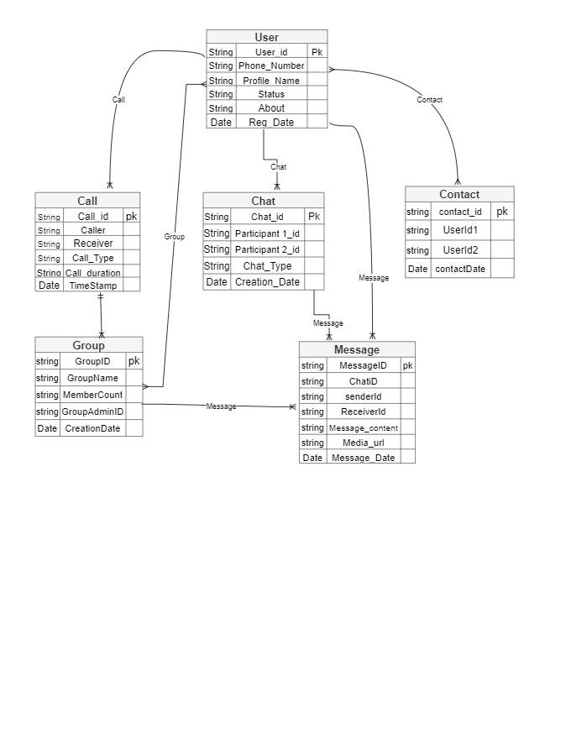

**Conclusion:**

In this exploration, we looked into how WhatsApp is put together, focusing on its design and how it deals with information. WhatsApp changed how we share stuff like photos and messages, making it simple to keep in touch and show how we feel. The design, especially how WhatsApp arranges and handles data, is like the strong base of a building.

The setup, made of parts like users, chats, calls, messages, contacts, and groups, is like the base of a house. Each part has its job, and they all work together to create the easy experience we enjoy using WhatsApp. Knowing this structure helps us see how WhatsApp manages all the things we do on the app, which is a big reason why so many folks enjoy using it.

**Technical Documentation Link:-** <https://docs.google.com/document/d/1_qmgWh0Jp7Dv8UA1PaQeKxLcU1GNfMeaaKRDfRLGbrc/edit?usp=sharing>

**Video Link:-**

<https://drive.google.com/file/d/1I7qOncwT6-CS9bOBU4H4tWDz7FlKhIEX/view?usp=sharing>

***Thank You AlmaBetter!***

#### 

#### 